Registration Form

YOUR CHILD’S DENTAL APPOINTMENT WILL BE BILLED TO THE DENTAL INSURANCE YOU PROVIDE.

Child’s First Name Last Name
Child’s Birthday Male Female
Street Address City State Zip Name of Child’s Insurance_________________________ Insurance ID # or Social Sec #:
Please attach a copy of insurance card – INSURANCE INFORMATION MUST BE FILLED IN TO BE SEEN

Custodial Parent Contact Information (Please print carefully)
Name Phone # Ok to Text? Yes No Ok to Leave a Voicemail? Yes No

Custodial Parent’s Signature: Date:
By signing my signature, I give permission for my child to have their routine dental check-up at their school with Giggles DDS and to allow a copy of results to be provided to Child Development Council of Franklin County if necessary.

Please Check:

FLUORIDE
YES - I give my permission for my child to have fluoride
NO - I do not give my permission for my child to have fluoride

PICTURES YES - I give my permission for my child to be photographed and/or video recorded
NO - I do not give my permission for my child to be photographed and/or video recorded

If dental insurance is through employment, please fill out the following:
Name of Policy Holder: Date of Birth of Policy Holder: Policy Holder’s ID/SSN: Policy Holder’s Phone #:
Insurance Company: Phone: Name and Phone # of Employer:

Medical Information – Does your child have any of the following?

Heart Murmur: Yes No
Indwelling Defibrillator: Yes No
Mitral Valve Prolapse: Yes No Pacemaker: Yes No

List Other Medical Conditions: Does the patient take medication daily? Yes No List your child’s medications:

I would like to pre-schedule my child for their 6-month dental checkup at their school: Yes No

What Giggles will be doing?

Polish Teeth
Dental Prophylaxis

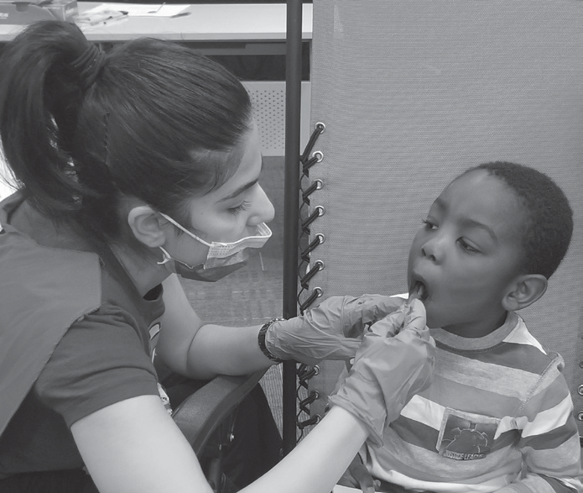
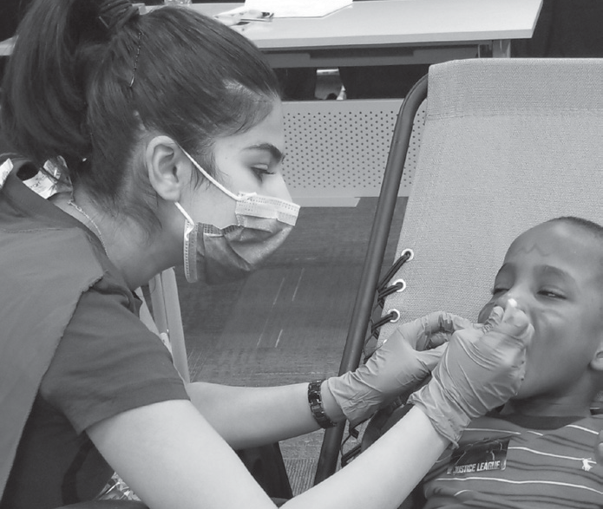
Commonly called a “Prophy”, is a treatment that involves polishing the teeth to control bacteria on the tooth and just beneath the gum line. To maintain healthy gums and teeth, it is typically performed twice a year, or once every six months.

Dental Exam
Comprehensive or Limited

Comprehensive Dental Exam
The dentist will examine and record each tooth extensively for chips or cracks, analyze the enamel to determine the risk for cavities, review existing fillings or restorations, and identify any abnormalities in the intraoral or extraoral soft tissues – the gums.

Limited Dental Exam
For numerous reasons, if the dentist is not able to complete a Com- prehensive Dental Exam they will continue with a shortened version. The dentist will still evaluate your child’s teeth and gums and identify any abnormalities or needs for restorative treatment.

Basically, making sure that each tooth is strong, healthy, and Giggly!

Strengthen Teeth
Fluoride

At the end of the appointment the dentist will apply Fluoride as a gel onto your child’s teeth. Fluoride, a naturally occurring mineral,
aids in rebuilding weekend tooth enamel and reverses early signs of tooth decay.

